IBM CLOUD CLI INSTALLATION:

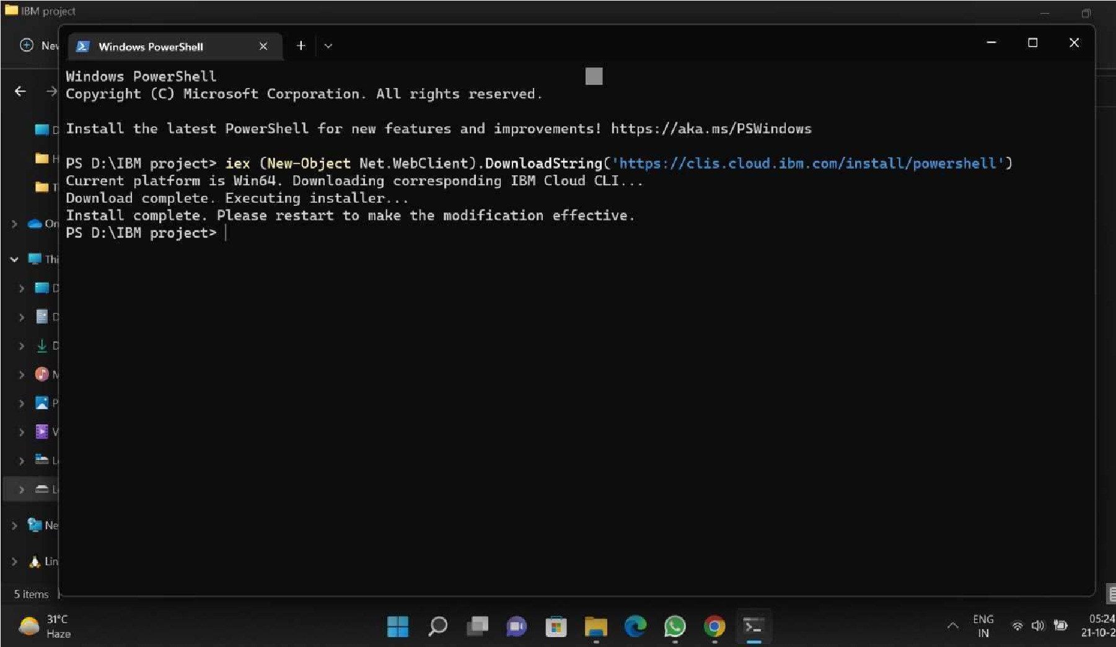

1